**Oak Grove Church of Christ Newsletter - 2025.07.13**

Website: oakgrovecofc.org

Facebook: facebook.com/oakgrovecofc **Sermon recordings**

Scan the QR code below with your phone’s cam, or visit oakgrovecofc.org/sermons.

**Speaker-AM:** Jamie Rinehart

**Title:** Scapegoat

**Recording**:

  
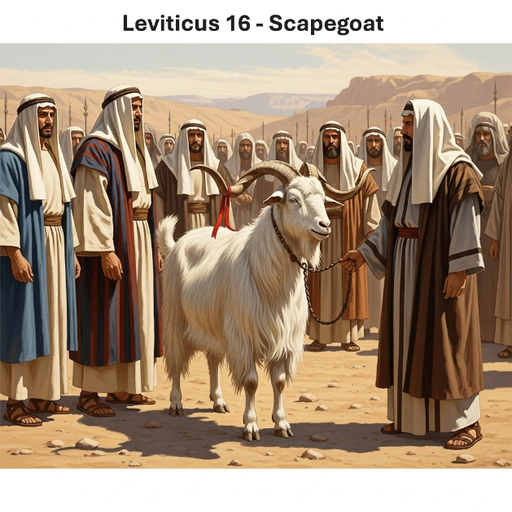

**Speaker-PM**: Brad Bunyard

**Title**: Lessons of Humility From Israel

**Recording**:





**News and Prayer Requests**

* Jean Branstetter, Kim Copeland, Mary Copeland, and Amos Crites were not feeling well.
* Nowak’s, LJ Vick, Josiah Crites, Jamie Glidden were out of town.
* Karen Romine is out of rehab and back.
* Singing August 8th@ 7:00PM in St. James.



**Articles**

**What is love? 7/14/2025 By Tyler Glidden**

*I Cor. 13:4-8. Love suffers long and is kind; love does not envy; love does not parade itself, is not puffed up; does not behave rudely, does not seek its own, is not provoked, thinks no evil; does not rejoice in iniquity, but rejoices in the truth; bears all things, believes all things, hopes all things, endures all things. Love never fails. But whether there are prophecies, they will fail; whether there are tongues, they will cease; whether there is knowledge, it will vanish away.*

This really is about spiritual gifts. When the spiritual gifts pass away, what are we left with? We are left with three things. Faith, Hope, and Love. This is the next best thing to having the spiritual gifts of healing, speaking in tongues, prophecy, or whatever spiritual gift that they had. This is the Agape type of love, which is that type of sacrificial love. This sacrificial love is patient, and kind. It is the foundation to how all the rest of the fruits of the Spirit to grow. It is incredibly difficult to be kind without loving your neighbor. It is hard to be patient or gentle or pursue peace when we don’t first show love. It is not jealous. Love does not look at others and wish that it has what others have. It certainly isn’t envious. Love does not brag and is not arrogant. That means when someone corrects our bad behavior or misinformation, or whatever it is that we might be doing wrong, we are to be humbled and take those things into consideration. Love does not rejoice in unrighteousness but does rejoice in truth. In Ephesians, we get this idea that we need to speak the truth, in love. And often we are good at one or the other. We are great at pointing out the truth, but not so good at delivering it in a way that is loving. Or we are good at being loving, while compromising on the truth. Both are important. We must rejoice in the truth and do it in a loving manner.

*John 15:12-17. My command is this: Love each other as I have loved you. Greater love has no one than this: to lay down one’s life for one’s friends. You are my friends if you do what I command. I no longer call you servants, because a servant does not know his master’s business. Instead, I have called you friends, for everything that I learned from my Father I have made known to you. You did not choose me, but I chose you and appointed you so that you might go and bear fruit—fruit that will last—and so that whatever you ask in my name the Father will give you. This is my command: Love each other.*

Jesus’ command to His disciples was that they loved each other. Jesus tells them more specifically that the love they should have for each other is the same type that He had for them. How did Jesus love His friends? He died for them. He even mentions that here in this text. Love is about sacrificing yourself for the sake of others. It’s about putting people above yourself. All of this to show Christ’s love for us.

What makes loving others difficult? As much as we might try to think that loving others is easy, the truth of the matter is... Some people are hard to love. Some people just get on our last nerves, don’t they? Some people don’t take the advice we give them or receive the love that we do give them? That doesn’t matter. You know what…? Some people are hard to love, but those are the people that need the most love from us. Think about Jesus. He came to this Earth to save us while we were still sinners. He knew that we would fall from grace. He knew that we would sin against Him. Yet He still died for each and every one of us. At times we are the ones who are hard to love.

Love takes effort to grow and is multifaceted. To grow love: Maybe we need more patience. Maybe more gentleness. Maybe kindness. But whatever it is that we must do to love better, we must do it. We cannot afford to not love others. The consequences are just too great.